# **ASSIGNMENT - 4**

1. **Write a program to print the average of three numbers entered by user by creating a class named 'Average' having a method to calculate and print the average. Define another driver class to demonstrate the basic operation.**

**Code:**

import java.util.Scanner;

public class Average {

    public static double AvgCal(int a, int b, int c) {

        double avg = (a + b + c) / 3.0;

        return avg;

    }

    public static void main(String[] args) {

        Scanner sc = new Scanner(System.in);

        System.out.println("Enter three Numbers : ");

        int a = sc.nextInt();

        int b = sc.nextInt();

        int c = sc.nextInt();

        double Avg = AvgCal(a,b,c);

        System.out.println("The Average of the Three Numbers is : " + Avg);

        sc.close();

    }

}

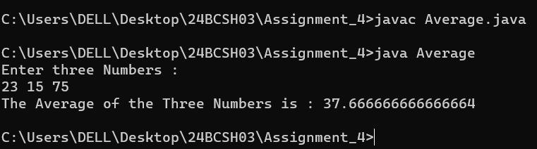**Output:**

1. **Write a program to create a class named 'Student' with members 'name', 'roll_no', ‘branch’. Declare two methods to input the student details and display the details of the student. Create a driver class to test the functionalities of the above class.**

**Code:**

import java.util.Scanner;

class Student

{

String name;

int roll;

String branch;

void input()

{

Scanner sc = new Scanner(System.in);

System.out.println("Enter Your Name:");

name= sc.nextLine();

System.out.println("Enter Your RollNo:");

roll = sc.nextInt();

System.out.println("Enter Your Branch");

branch = sc.next();

sc.close();

}

void Display()

{

System.out.println("Student Details:");

System.out.println("Name: " + name);

System.out.println("RollNo: " + roll);

System.out.println("Branch: " + branch);

}

public static void main(String[] args)

{

Student obj = new Student();

obj.input();

obj.Display();

}

}

**Output:**

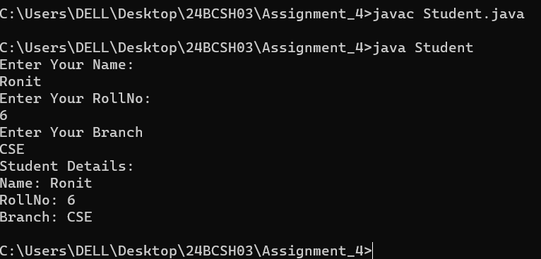

1. **Declare a class Complex with member real and imaginary part. Define a method initialise() to input the two complex numbers, show() to display the complex number and add() to add the two complex numbers. Declare another class to illustrate the operations of the Complex class.**

**Code:**

import java.util.Scanner;

class Complex {

    int real, img;

    void initialise(int r, int i) {

        this.real = r;

        this.img = i;

    }

    void show() {

        System.out.println(real + " + " + img + "i");

    }

    Complex add(Complex c) {

        Complex temp = new Complex();

        temp.real = this.real + c.real;

        temp.img = this.img + c.img;

        return temp;

    }

    public static void main(String[] args) {

        Scanner sc = new Scanner(System.in);

        Complex c1 = new Complex();

        Complex c2 = new Complex();

        System.out.println("Enter Real and Imaginary part of First Complex Number:");

        int r1 = sc.nextInt();

        int i1 = sc.nextInt();

        c1.initialise(r1,i1);

        System.out.println("Enter Real and Imaginary part of Second Complex Number:");

        int r2 = sc.nextInt();

        int i2 = sc.nextInt();

        c2.initialise(r2,i2);

        System.out.print("First Complex Number: ");

        c1.show();

        System.out.print("Second Complex Number: ");

        c2.show();

        Complex c3 = c1.add(c2);

        System.out.print("Sum = ");

        c3.show();

        sc.close();

    }

}

**Output:**

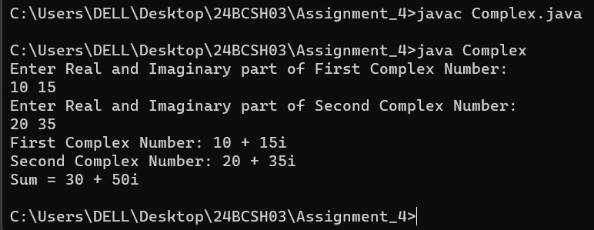

1. **Write a program to print the area of a rectangle by creating a class named 'Area' having two methods. First method named as 'setDim ()' takes length and breadth of rectangle as parameters and the second method named as 'getArea ()' returns the area of the rectangle. Length and breadth of rectangle are entered through keyboard. [use ‘this’ keyword]**

**Code:**

import java.util.Scanner;

class Area {

    int length, breadth;

    void setDim(int length, int breadth) {

        this.length = length;

        this.breadth = breadth;

    }

    int getArea() {

        return length * breadth;

    }

    public static void main(String[] args) {

        Scanner sc = new Scanner(System.in);

        System.out.print("Enter Length and Breadth : ");

        int l = sc.nextInt();

        int b = sc.nextInt();

        Area area = new Area();

        area.setDim(l, b);

        System.out.println("The Area of the Rectangle is = " + area.getArea());

        sc.close();

    }

}

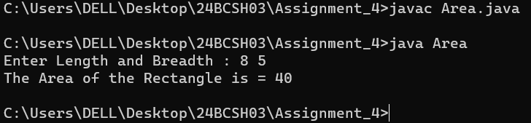**Output:**

1. **Write a program to declare a class employee with data members empid, ename, dept, sal. Add a method getData(), putData() to accept and display the details of n employees. Define a driver class to create the objects of employee class and perform basic operations.**

**Code:**

import java.util.Scanner;

class Employee {

    int empid;

    String ename, dept;

    double sal;

    void getData(int id, String name, String dep, double s) {

        empid = id;

        ename = name;

        dept = dep;

        sal = s;

    }

    void putData() {

        System.out.println(empid + " | " + ename + " | " + dept + " | " + sal);

    }

    public static void main(String[] args) {

        Scanner sc = new Scanner(System.in);

        System.out.print("Enter number of employees: ");

        int n = sc.nextInt();

        sc.nextLine();

        Employee[] arr = new Employee[n];

        for (int i = 0; i < n; i++) {

            arr[i] = new Employee();

            System.out.println("Enter details of employee " + (i + 1));

            System.out.print("Enter Emp ID: ");

            int id = sc.nextInt();

            sc.nextLine();

            System.out.print("Enter Name: ");

            String name = sc.nextLine();

            System.out.print("Enter Dept: ");

            String dept = sc.nextLine();

            System.out.print("Enter Salary: ");

            double sal = sc.nextDouble();

            sc.nextLine();

            arr[i].getData(id, name, dept, sal);

        }

        System.out.println("\nEmployee Details:");

        for (Employee e : arr) {

            e.putData();

        }

        sc.close();

    }

}

**Output:**

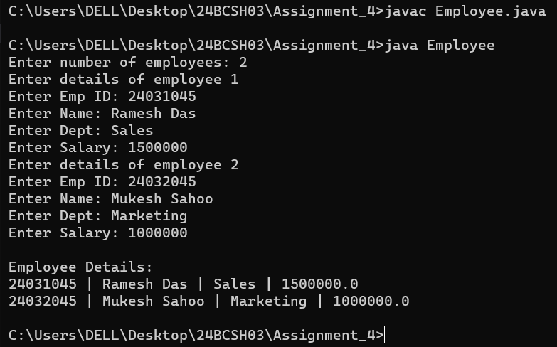

1. **Define a class Student having the attribute regNo, stdName, branch and CGPA. Write 2 methods to accept and display the student details. Read the details of 50 students using an array of Student class object. Display the student details who has secured the highest CGPA.**

**Code:**

class CGPA {

    int regNo;

    String stdName, branch;

    double CGPA;

    void accept(int reg, String name, String br, double cgpa) {

        regNo = reg;

        stdName = name;

        branch = br;

        CGPA = cgpa;

    }

    void display() {

        System.out.println(regNo + " | " + stdName + " | " + branch + " | " + CGPA);

    }

    public static void main(String[] args) {

        java.util.Scanner sc = new java.util.Scanner(System.in);

        CGPA[] s = new CGPA[50];

        for (int i = 0; i < 5; i++) {

            s[i] = new CGPA();

            System.out.println("Enter details of Student " + (i + 1));

            System.out.print("Enter Redg. No. : ");

            int reg = sc.nextInt();

            sc.nextLine();

            System.out.print("Enter Name : ");

            String name = sc.nextLine();

            System.out.print("Enter Branch : ");

            String branch = sc.nextLine();

            System.out.println("Enter CGPA : ");

            double cgpa = sc.nextDouble();

            sc.nextLine();

            s[i].accept(reg, name, branch, cgpa);

        }

        int maxIndex = 0;

        for (int i = 1; i < 5; i++) {

            if (s[i].CGPA > s[maxIndex].CGPA) {

                maxIndex = i;

            }

        }

        System.out.println("\nStudent with Highest CGPA:");

        s[maxIndex].display();

        sc.close();

    }

}

**Output:**

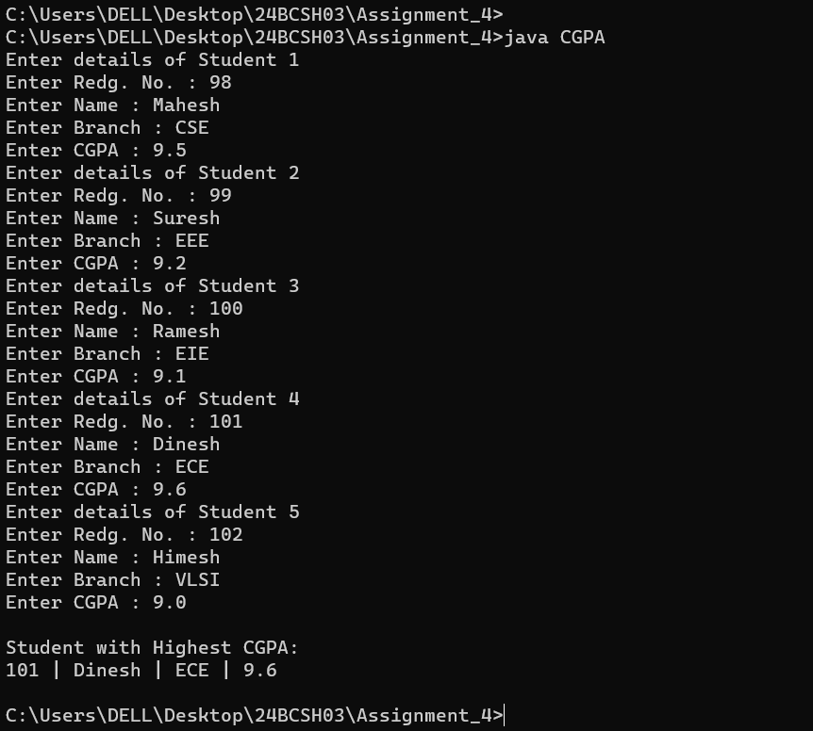

1. **Define a class ‘Box’ that uses a parameterized constructor to initialize the dimensions of a box. The dimensions of the Box are width, height, depth. The class should have a method that can return the volume of the box. Create an object of the Box class and test the functionalities[use this keyword].**

**Code:**

import java.util.Scanner;

class Volume {

    double width, height, depth;

    Volume(double width, double height, double depth) {

        this.width = width;

        this.height = height;

        this.depth = depth;

    }

    double volume() {

        return width * height * depth;

    }

    public static void main(String[] args) {

        Scanner sc = new Scanner(System.in);

        System.out.print("Enter the Width of the Box : ");

        double w = sc.nextDouble();

        System.out.print("Enter the Height of the Box : ");

        double h = sc.nextDouble();

        System.out.print("Enter the Depth of the Box : ");

        double d = sc.nextDouble();

        Volume b = new Volume(w,h,d);

        System.out.println("The Volume of the Box is  = " + b.volume());

        sc.close();

    }

}

**Output:**

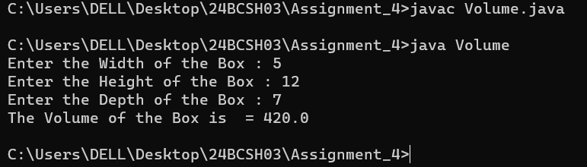

1. **Design a class ‘ComplexNum’ to manipulate Complex numbers having data members as real and img. The class should have a parameterized constructor to initialize its data members. It should also have methods displayCompNumber() to display the complex number (in the format 5+3i for example), addCompNumber() to add two Complex numbers. Test these methods by creating main method in another class.**

**Code:**

import java.util.Scanner;

class ComplexNum {

    int real, img;

    ComplexNum(int r, int i) {

        this.real = r;

        this.img = i;

    }

    void displayCompNumber() {

        System.out.println(real + "+" + img + "i");

    }

    ComplexNum addCompNumber(ComplexNum c) {

        return new ComplexNum(this.real + c.real, this.img + c.img);

    }

    public static void main(String[] args) {

        Scanner sc = new Scanner(System.in);

     System.out.print("Enter the Real and Imaginary part of the First Complex Number : ");

        int r1 = sc.nextInt();

        int i1 = sc.nextInt();

  System.out.print("Enter the Real and Imaginary part of the Second Complex Number : ");

        int r2 = sc.nextInt();

        int i2 = sc.nextInt();

        ComplexNum c1 = new ComplexNum(r1, i1);

        ComplexNum c2 = new ComplexNum(r2, i2);

        System.out.print("First: ");

        c1.displayCompNumber();

        System.out.print("Second: ");

        c2.displayCompNumber();

        ComplexNum sum = c1.addCompNumber(c2);

        System.out.print("Sum: ");

        sum.displayCompNumber();

        sc.close();

    }

}

**Output:**

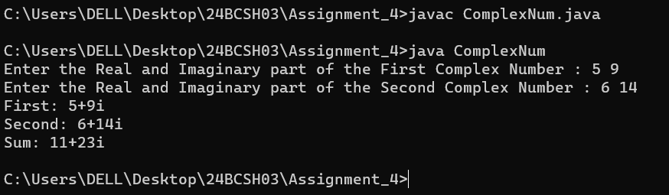

1. **Design a class ‘Point’ with data members as xCo and yCo. The class should have a parameterized constructor to initialize its data members. Define a method distanceBetPoints() which returns the distance between two points.**

**Code:**

import java.util.Scanner;

public class Distance {

    int xCo, yCo;

    Distance(int x, int y) {

        this.xCo = x;

        this.yCo = y;

    }

    double distanceBetPoints(Distance p) {

        return Math.sqrt(Math.pow(this.xCo - p.xCo, 2) + Math.pow(this.yCo - p.yCo, 2));

    }

    public static void main(String[] args) {

        Scanner sc = new Scanner(System.in);

        System.out.print("Enter the X and Y cordinates of the First Point : ");

        int x1 = sc.nextInt();

        int y1 = sc.nextInt();

        System.out.print("Enter the X and Y cordinates of the Second Point : ");

        int x2 = sc.nextInt();

        int y2 = sc.nextInt();

        Distance p1 = new Distance(x1,y1);

        Distance p2 = new Distance(x2,y2);

        System.out.println("The Distance is  = " + p1.distanceBetPoints(p2));

        sc.close();

    }

}

**Output:**

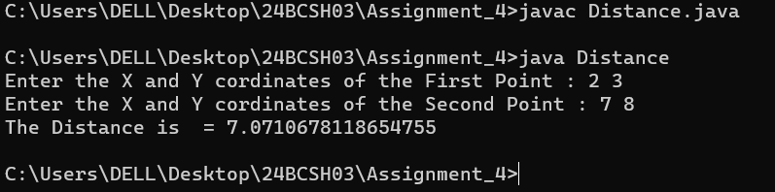

1. **Design a class ‘Time’ having data members as hour, minute and second. The class should have a parameterized constructor to initialize its data members. It should also have methods displayTime() to display the time in HH:MM:SS format and addTime() to add two times. Test these methods by creating a main method in another class.**

**Code:**

import java.util.Scanner;

class Time {

    int hour, minute, second;

    Time(int h, int m, int s) {

        this.hour = h;

        this.minute = m;

        this.second = s;

    }

    void displayTime() {

        System.out.printf("%02d:%02d:%02d\n", hour, minute, second);

    }

    Time addTime(Time t) {

        int totalSec = this.second + t.second;

        int totalMin = this.minute + t.minute + totalSec / 60;

        int totalHr = this.hour + t.hour + totalMin / 60;

        return new Time(totalHr, totalMin % 60, totalSec % 60);

    }

    public static void main(String[] args) {

        Scanner sc = new Scanner(System.in);

        System.out.print("Enter the Hours Minutes and Seconds of the First Time : ");

        int h1 = sc.nextInt();

        int m1 = sc.nextInt();

        int s1 = sc.nextInt();

        System.out.print("Enter the Hours Minutes and Seconds of the Second Time : ");

        int h2 = sc.nextInt();

        int m2 = sc.nextInt();

        int s2 = sc.nextInt();

        Time t1 = new Time(h1,m1,s1);

        Time t2 = new Time(h2,m2,s2);

        System.out.print("First Time: ");

        t1.displayTime();

        System.out.print("Second Time: ");

        t2.displayTime();

        Time sum = t1.addTime(t2);

        System.out.print("Sum: ");

        sum.displayTime();

        sc.close();

    }

}

**Output:**

